

SCHOOL *of* BUSINESS AND TECHNOLOGY

Department of Engineering and Aviation Sciences

**Virtual Reality**

**Konnet Wayne**

Advisor: Dr. Zhang

February 18, 2021

Virtual Reality

By

Konnet Wayne

Submitted to the Department of Engineering and Aviation Sciences in partial fulfillment of the requirements for the degree of Bachelor of Science in Engineering at the

UNIVERSITY OF MARYLAND EASTERN SHORE

Date

February 18, 2021

The author hereby grants the University of Maryland Eastern Shore permission to reproduce and distribute publicly, paper and or electronic copies of this document in whole or in parts.

Authors Konnet Wayne

Signature



Date February 18, 2021

Department of Engineering and Aviation Sciences



Certified by



Special notice for formatting for the whole report:

1. Keep the formatting consistent (learn and apply the MS ‘Styles’ in formatting). Do not change any format but just apply corresponding styles as listed.
2. Do not add any blank rows but use BREAKS, except the end of a table. BREAKS can be found on ‘Page Layout’ → ‘Page Setup’ → ‘Breaks’.
3. Every figure or picture must be mentioned in the text first then can appear. When it is mentioned, use the cross-reference.
4. Every figure or picture in the text must be accompanied with the caption and detailed description.
5. Only third person is allowed (except the Conclusion and Acknowledge sections). Never use ‘we’, ‘our’, ‘you’, etc. anywhere else (use the ‘find’ function of MS Office to double check).
6. Use ‘do not’ other than ‘don’t’, and so forth.
7. You can copy any reference information from anywhere, but anything not from yourself must be refereed and the original information must be included in the Reference section.
8. The reference must be organized with professional software such as ‘Endnote Web’, ‘Mendeley’, etc. Use IEEE reference format.
9. Try Grammarly. It can help in fixing typos and grammar errors.
10. If you get ‘Styles’ messed up, the easiest way is to start over, to open this blank template and copy-paste contents into it.

List of Contents

List of Contents 4

List of Figures 2

List of Tables 3

Abstract 4

1. Introduction 5

1.1 Backgound/Motivation 5

1.2 Objective 5

1.3 Design Requirements 5

1.4 Design Constraints 5

1.5 Design Methods 5

2. Project Description 6

2.1 System Description 6

2.2 System Diagram 6

2.3 System Functions 6

3. Implementation Plan 8

3.1 Tasks 8

3.2 Team Organization 9

3.2.1 Responsibility of Team Member 1. 9

3.3 Timeline/Milestones/Delivery Plan 9

4. Implementation 10

4.1 Implementation of Task 1. 10

4.2 Implementation of Task 1. 10

5. Conclusion. 11

Acknowledgement 12

Appendix 13

A. Component Specs 13

B. Source Code. 13

REFERENCES 14

List of Figures

Fig. 1. Example: Element 4D 5

Fig. 2. Example: Hololens ……………………………………………………………………………………………………6

Fig. 3. Example: Virtual Military …………………………………………………………………………………………6

Fig. 4. System Flowchart ..……………………………………………………………………………………………….10

Fig. 5. Building Construction ..…………………………………………………………………………………………11

Fig. 6 Touch ……………………………………………………………………………………………………………………12

Fig. 7. Door …………………………………………………………………………………………………………….………13

Fig. 8. Zombies …………………………………………………………………………………………………………………13

Fig. 9. Player Code ……………………………………………………………………………………………………………14

Fig. 10. Gun Control ………………………………………………………………………………………………………….14

Fig. 11a. Question …..…….…………………………………………………………………………………………………….14

Fig. 11b. Question ………………………..……………………………………………………………………………………..15

Fig. 11c. Question ……………………………………………………………………………………………………………….15

List of Tables

Table 1. Project Timeline and Delivery Plan 10

Abstract

1. Introduction

## Backgound/Motivation

The purpose of this virtual reality design project is to teach student basic circuit concept. What is Virtual Reality? Virtual Reality (VR) is a completely digital experience that is viewed inside a closed visual environment (htt)[1]. Virtual Reality is the process of creating a 3D model of that environment it can be created by using a software design to create a 3D experience like Unity and Vuforia. The first virtual reality that was created was the Sensorama by Morton Heilig. The use of the term “virtual reality,” however, was first used in the mid-1980s when Jaron Lanier, founder of VPL Research, began to develop the gear, including goggles and gloves, needed to experience what he called “virtual reality”[2]. Some of the related technologies to think about when talking about Virtual Reality are Augmented Reality and Mixed Reality. Because Virtual reality is just a digital environment experience it was limit of only education.

In other to move to training, it evolve to another branch called Augmented creating a subbranch called Mixed reality to give users a full experience of the real world not just digital. Augmented reality modified the view of the real world. It is constructed using a 360-degree camara to capture the real environment of a desire place and create a 3D experience of that place. Mixed reality is the merging of the real and virtual worlds to produce new environments and visualizations where physical and digital objects co-exist and interact in real time. Speaking of virtual reality, so of the solutions it had solve are interactivity, safety, delivery, and visualization[3]. Virtual Reality create a safe environment to conduct training in the work placed by replicating the training cite using the evolved branch augmented reality to decrease the risk of accidents. It delivers lessons in a way that student will have an interactive experience. It also helps individual visualize places they have never been to. Some of the tool use with visual reality are HTC VIVE, Oculus Rift, Gear VR, and Zeiss VR One.

There are that three examples that will be talk about. The first example will show how virtual reality works, the second example will show how the evolved branch augmented reality works, and the third example will show how the subbranch mixed reality works. The first example is about how grade schools uses virtual reality that teaches students about chemistry.

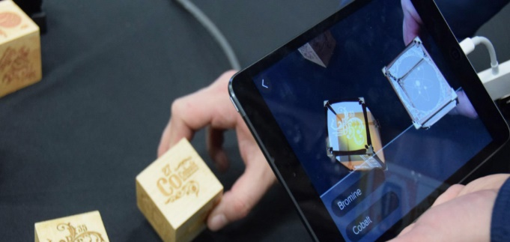

1. Example: Elements 4D

Elements 4D uses AR to make chemistry more fun and engaging. First, users need to make paper cubes from special element blocks. Then, they just need to place the cubes in front of their device’s camera to see representations of chemical elements, their names, and their atomic weights. To explore elements, students can bring together two cubes to find out if elements react and to see the chemical reaction[4]. The second example is about how medical school uses mixed reality of create a hands-on surgeries experience for med students.



1. Example: HoloLens

One of the ways to ease the process of learning is to use Mixed Reality for anatomy and improve not only the learning curve but the education in general. Using Microsoft HoloLens, users can pull the human body apart and investigate the organs and limbs piece by piece. The Mixed Reality application allows students to learn more about the human body and get in-depth information about a particular organ[5]. The third example is about how the military uses augmented reality to create a safe training environment for soldiers.

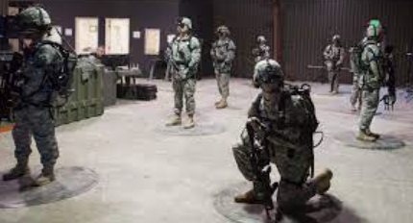

1. Example: Virtual Military training

Augmented reality provides an environment where soldiers can train effectively, adding virtual effects and objects like vehicles and enemies to the physical world. AITT helps make such training more accessible and cuts costs. While training plays a vital role in the military sector, it’s not always possible to put soldiers in a particular location for training. Augmented reality technology is used to create an environment required for training soldiers, letting them train more often[6]. When talking about virtual reality, some factors to consider are global, cultural, social, environmental, and economic. Virtual Reality has an increase rate in income,helps people connect with the environment,reduces the need for human interaction**,** it could be used to reduce the stress of covid 19 around the world, and it connects people of different cultural background.

## Objective

Create a fun and educative game that will help students better understand and solve circuit.

## Design Requirements

1. The Virtual Reality Learning game will be a Shooting game.
2. Players will solve a circuit to have an upgrade of their gun.
3. Mystery boxes (weapons, coins, or protection) will be placed in random places for players to find.
4. There will be 12 puzzle questions for users to solve: six questions per scenario.
5. User will search, fight and defeat to be able to find the puzzles to solve.
6. Student will learn how to solve parallel and series circuit in two different scenarios.

A wizard puts a player into a dimension of horror were there are total darkness, fire, and monsters that he/she must defeat. Little do the player know that this is only the beginning. There is new dimension with a different scenario at the end of every other dimension. The player has 20 minutes to fight his/her way out of each scenario while solving circuits until the wizard can be find and defeated.

## Design Constraints

For the design of circuit virtual reality game, there are only one constraint, HTC VIVE kit. HTC VIVE kit allows user to move in the 3D game space. Also, HTC VIVE have a motion-tracker handheld controller that allows user to interact with the environment. For the virtual game to work, the software for the game must be downloaded on a laptop that has a WIFI which will then be connected to an HTC VIVE.

## Design Methods

The first step is to download the software called Unity onto the computer and setup a unity account. The second step is created a 3D design in the scene screen of unity using component in the main menu and write a C# script by right clicking on the command section within unity and clicking on C#. The third step is to get the HTC VIVE Kit and connect the 3D game to the device using Bluetooth. The fourth step is to get at least three players to test the game.

## Standards

No Standards

1. Project Description

## System Description

A C# code is attached to each scenario that tells each design component how to operate when the game is on and been play by the user. A first controller will be placed within the game that will allow user to move around each scenario. The computer with the virtual reality game is connected to the HTC VIVE kit to allow player to have a 3D view.

## System Diagram (or Flow Chart)

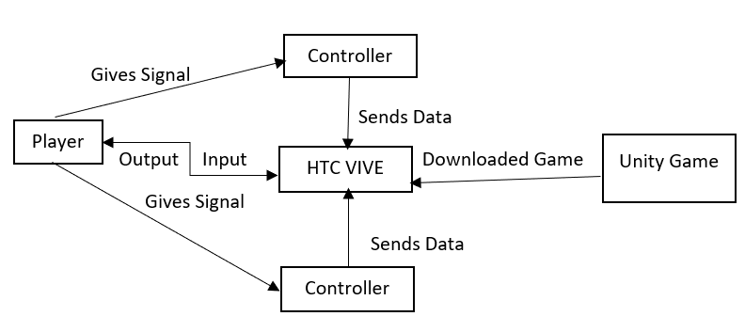

Fig. 4. System Diagram

## System Functions

1. When the player presses the play button on the HTC VIVE, the game will display an instruction on how to play and what is expected of the player.
2. As the player touches the trackpad on the controllers, the controllers send a data that will allow the player to move around in each scenario, also as they move, puzzles will be place at specific point for the player to solve.
3. Implementation Plan

## Tasks

Task 1. Research

Subtask 1. Topic.

A design topic was chosen, and research was conducted.

Task 2. Building Design.

Subtask 1. Construction

The building has a scale of 1000 by 1000. There are two floors. The first floor has a total of 10 rooms and the second floor has a total of 1 room.

Subtask 2. Add Materials

The texture of the building will be added.

Task 3. Scenario one; Haunted House

Subtask 1. Effects

Particle System, Lighting, and sound

Subtask 2. Objects

Object of different kind will be added (crown, ghost, skeleton, etc.)

Subtask 3. Puzzles

Six puzzles of a circuits in parallel will be placed in random rooms on the first floor.

Subtask 4. C#

A C# code will be written for all the objects in the scenario one.

Subtask 5. Assemble

The C# code will be attached to the objects and assemble as one code.

Task 4. Scenario two; Attack

Subtask 1. Environment

A forest like environment will be added on the second floor.

Subtask 2. Creature

Creatures of the same kind will be added.

Subtask 3. Puzzles

Six puzzles of a circuits in series will be placed in random rooms on the first floor.

Subtask 4. C#

A C# code will be written for all the objects in the scenario one.

Subtask 5. Assemble

The C# code will be attached to the objects and assemble as one code.

Task 5. Scenario Assemble

The two scenarios will be combined.

Task 6. Testing

The game will be tested to make certain that it works.

## Team Organization

### Responsibility of Team Member 1.

Task 1, Task 2, Task 3, Task 4, Task 5, Task 6

## Timeline/Milestones/Delivery Plan

1. Project Timeline and Delivery Plan

|  |  |  |
| --- | --- | --- |
| Time | Task | Comments |
| Konnet Wayne |
| Week 1 | Task 1 | Research on educative virtual reality game was conducted. |
| Week 2 | Task 2; Subtask 1 | The build construction will be delivered. |
| Week 3 | Task 2; Subtask 2 | Texture added to varies part of the building will be delivered |
| Week 4 | Task 3; Subtask 1 | Effects will be displayed |
| Week 5 | Task 3; Subtask 2 | Objects will be delivered |
| Week 6 | Task 3; Subtask 3 | Puzzles will be displayed |
| Week 7 | Task 3; Subtask 3 | Puzzles will be displayed |
| Week 8 | Task 3; Subtask 4 | The attach code will be displayed |
| Week 9 | Task 3; Subtask 4 | The attach code will be displayed |
| Week 10 | Task 3; Subtask 5 | The assemble code will be displayed |
| Week 11 | Task 3; Subtask 5 | Scenario one will be presented |
| Week 12 | Task 4; Subtask 1 | Environment will be delivered |
| Week 13 | Task 4; Subtask 2 | Creatures will be displayed |
| Week 14 | Task 4; Subtask 3 | Puzzles will be displayed |
| Week 15 | Task 4; Subtask 3 | Puzzles will be displayed |
| Week 16 | Task 4; Subtask 4 | The attach code will be displayed |
| Week 17 | Task 4; Subtask 4 | The attach code will be displayed |
| Week 18 | Task 4; Subtask 5 | The assemble code will be displayed |
| Week 19 | Task 4; Subtask 5 | Scenario two will be presented |
| Week 20 | Task 5 | Combined scenario will be displayed |
| Week 21 | Task 6 | Testing results will be presented |
| Week 22 | Task 6 | Design finalization will be delivered along will all documentation. |

1. Implementation

## Implementation of Task 1.

Research was conducted online. Multiple sources were review and the most informative sources were used in the report.

## Implementation of Task 2.

The building design was constructed using a cube in the 3D tap within unity. The cube was placed in the scene screen within unity. A desire position, rotation, and scale were given in the x, y, and z plane. The cube was than copy multiple time to create the walls, ground, and roof of the building. Next, texture assets were downloaded and placed in the assets window of unity. The texture was then placed on the cubes to design two stories building.

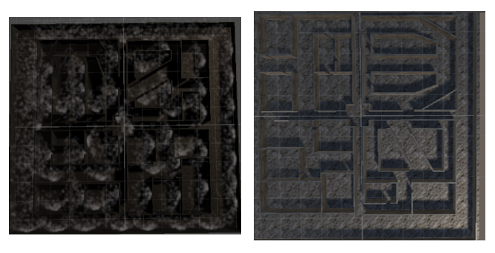

Fig. 5. Building Construction

## Implementation of Task 3.

Scenario one: Haunted house will be design on the first floor. A point, spot, and direction light will be added on the first floor of the building. The lights will be placed on a lower scale to create a dark environment. Next, the fog particle system will be placed on the ground of the entire first floor. Then, different horrific sound will be added. Later, objects will be placed in varies room, some in the ground, some on the ground and some above the ground. The six puzzles will then be placed in random room for the players to find and solve. Lastly, C# scripts and attached to objects. After it is done, another C# script will be written to call the scripts attached to the objects.

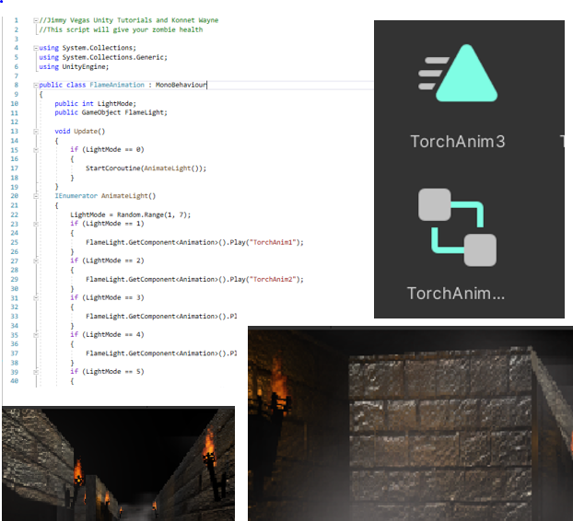

Fig. 6. Touch

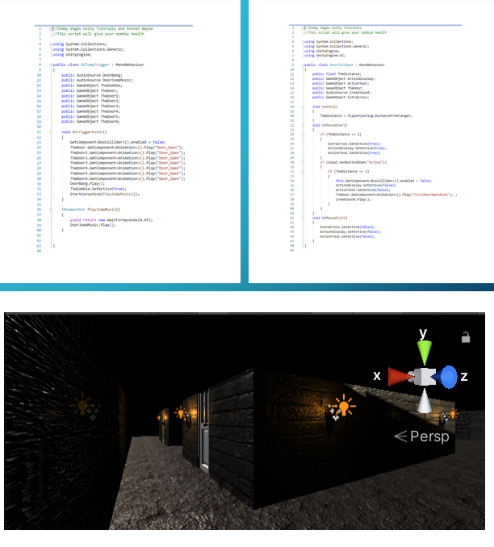

Fig. 7. Door

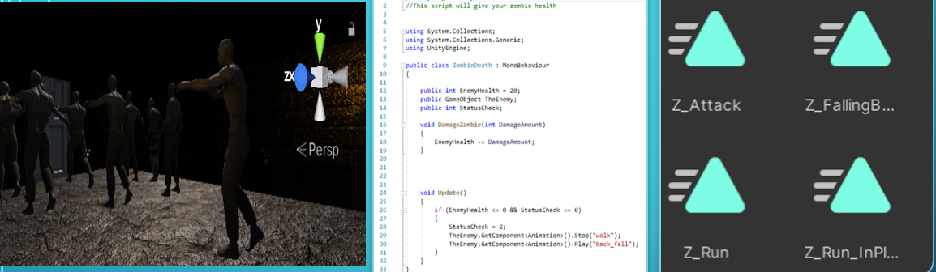

Fig. 8. Zombies

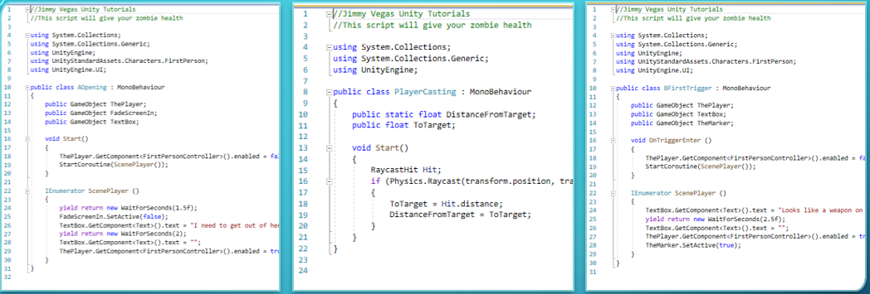

Fig. 9. Player Code

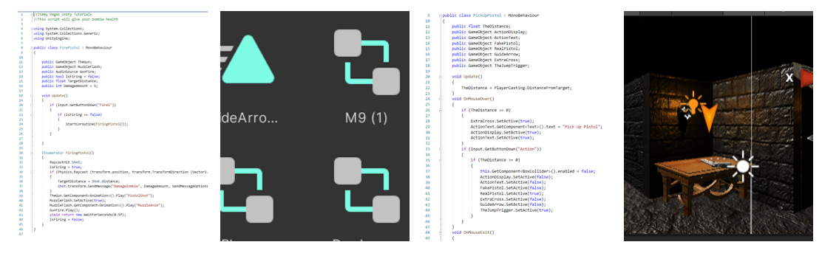

Fig. 10. Gun control

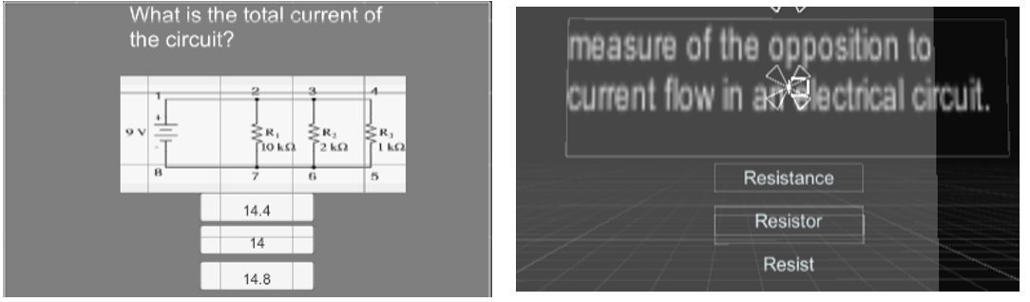

Fig. 11a. Questions

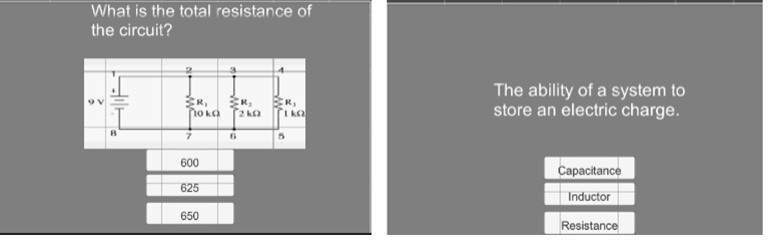

Fig. 11b. Questions

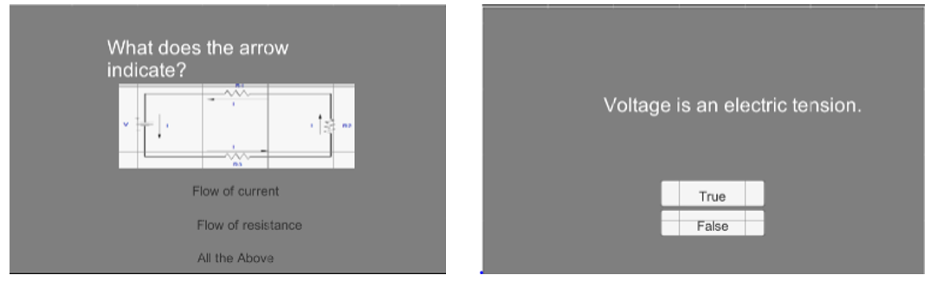

Fig. 11c. Questions

## Implementation of Task 4.

Scenario one: Attacks will be design on the first floor. A point, spot, and direction light will be added on the first floor of the building. The lights will be placed on a higher scale to create a bright environment. Next, a forest like environment will be created using trees, grass, and rivers. Later, creates will be placed at random spots in the forest that will try to attack the player. The six puzzles will then be placed in random area of the forest for player to find and solve. Lastly, C# scripts and attached to objects. After it is done, another C# script will be written to call the scripts attached to the objects.

## Implementation of Task 5.

The two scenarios will be assembled using a C# script.

## Implementation of Task 6.

The game will be tested by multiple players to prove its effectiveness in educating kids.

1. Project evaluation
2. Conclusion

* Project summary

This game is constructed to help students understand the basic concept of solving circuit. It is divided into scenario. The first one is the haunted house which help students understand parallel circuit. The second one is the attack which help students understand a series circuit. Students used HTC VIVE to have the 3D environment of the game of solve the puzzle.

* Learning and practice experience

While doing this game, the concept of how to construct a 3D game using component and C# code within unity was learned.

* Future plan (how to improve)

The future plan of this 3D virtual reality game is to add more scenario and puzzles of different kind of circuit solving method.

Acknowledgement

Appendix

1. Component Specs
2. Source Code.

REFERENCES

[1] D. Vantrease, R. Schreiber, M. Monchiero, M. McLaren, N. P. Jouppi, M. Fiorentino*, et al.*, "Corona: System Implications of Emerging Nanophotonic Technology," in *Computer Architecture, 2008. ISCA '08. 35th International Symposium on*, 2008, pp. 153-164.

[2] X. Zhang and A. Louri, "A multilayer nanophotonic interconnection network for on-chip many-core communications," in *Design Automation Conference (DAC), 2010 47th ACM/IEEE*, 2010, pp. 156-161.

[3] C. Batten, A. Joshi, J. Orcutt, A. Khilo, B. Moss, C. Holzwarth*, et al.*, "Building manycore processor-to-DRAM networks with monolithic silicon photonics," in *High Performance Interconnects, 2008. HOTI '08. 16th IEEE Symposium on*, 2008, pp. 21-30.

[4] Y. Pan, P. Kumar, J. Kim, G. Memik, Y. Zhang, and A. Choudhary, "Firefly: illuminating future network-on-chip with nanophotonics," in *IEEE/ACM Intl. Symp. on Computer Architecture (ISCA)*, 2009, pp. 429-440.

[5] N. Kirman, M. Kirman, R. K. Dokania, J. F. Martinez, A. B. Apsel, M. A. Watkins*, et al.*, "Leveraging Optical Technology in Future Bus-based Chip Multiprocessors," in *Microarchitecture, 2006. MICRO-39. 39th Annual IEEE/ACM International Symposium on*, 2006, pp. 492-503.

[6] J. M. Cianchetti, C. J. Kerekes, and H. D. Albonesi, "Phastlane: a rapid transit optical routing network," in *Proceeding of: 36th International Symposium on Computer Architecture (ISCA)*, 2009, pp. 441-450.

[7] A. Shacham, K. Bergman, and L. P. Carloni, "Photonic Networks-on-Chip for Future Generations of Chip Multiprocessors," *Computers, IEEE Transactions on,* vol. 57, pp. 1246-1260, 2008.

[8] A. Shacham, K. Bergman, and L. P. Carloni, "On the Design of a Photonic Network-on-Chip," in *First International Symposium on Networks-on-Chip, 2007. NOCS 2007*, 2007, pp. 53-64.

[9] M. Kwai Hung, Y. Yaoyao, W. Xiaowen, Z. Wei, L. Weichen, and X. Jiang, "A Hierarchical Hybrid Optical-Electronic Network-on-Chip," in *VLSI (ISVLSI), 2010 IEEE Computer Society Annual Symposium on*, 2010, pp. 327-332.

[10] D. Ding and D. Z. Pan, "OIL: a nano-photonics optical interconnect library for a new photonic networks-on-chip architecture," presented at the Proceedings of the 11th international workshop on System level interconnect prediction, San Francisco, CA, USA, 2009.

[11] A. Joshi, C. Batten, K. Yong-Jin, S. Beamer, I. Shamim, K. Asanovic*, et al.*, "Silicon-photonic clos networks for global on-chip communication," in *Networks-on-Chip, 2009. NoCS 2009. 3rd ACM/IEEE International Symposium on*, 2009, pp. 124-133.

[12] D. Vantrease, R. Schreiber, M. Monchiero, M. McLaren, N. P. Jouppi, M. Fiorentino*, et al.*, "Corona: system implications of emerging nanophotonic technology," in *Proc. 35th IEEE/ACM Int'l Symp. Computer Architecture (ISCA)*, 2008, pp. 153-164.

[13] L. Zhang, E. Regentova, and X. Tan, "A 2D-Torus Based Packet Switching Optical Network-on-Chip Architecture," presented at the *IEEE International Symposium on Photonics and Optoelectronics* (SOPO 2011), Wuhan, China, 2011.

[14] L. Zhang, E. E. Regentova, and X. Tan, "Packet switching optical network-on-chip architectures," *Comput. Electr. Eng.,* vol. 39, pp. 697-714, 2013.

[15] G. Huaxi, X. Jiang, and W. Zheng, "A novel optical mesh network-on-chip for gigascale systems-on-chip," in *Circuits and Systems, 2008. APCCAS 2008. IEEE Asia Pacific Conference on*, 2008, pp. 1728-1731.

[16] G. Huaxi, X. Jiang, and Z. Wei, "A low-power fat tree-based optical Network-On-Chip for multiprocessor system-on-chip," in *Design, Automation & Test in Europe Conference & Exhibition, 2009. DATE '09.*, 2009, pp. 3-8.

[17] Y. Yaoyao, X. Jiang, H. Baihan, W. Xiaowen, Z. Wei, W. Xuan*, et al.*, "3-D Mesh-Based Optical Network-on-Chip for Multiprocessor System-on-Chip," *Computer-Aided Design of Integrated Circuits and Systems, IEEE Transactions on,* vol. 32, pp. 584-596, 2013.

[18] A. Shacham, K. Bergman, and L. P. Carloni, "Photonic networks-on-chip for future generations of chip multiprocessors," *IEEE Trans. Computers,* vol. 57, pp. 1246-1260, 2008.

[19] A. W. Poon, F. X. Xu, and X. Luo, "Cascaded active silicon microresonator array cross-connect circuits for WDM networks-on-chip," in *Proc. SPIE*, 2008, p. 689812.

[20] M. Lipson, "Compact Electro-Optic Modulators on a Silicon Chip," *IEEE Journal of Selected Topics in Quantum Electronics,* vol. 12, pp. 1520-1526, 2006.

[21] M. Lipson, "Guiding, modulating, and emitting light on Silicon-challenges and opportunities," *Lightwave Technology, Journal of,* vol. 23, pp. 4222-4238, 2005.

[22] T. Xianfang, Y. Mei, Z. Lei, J. Yingtao, and Y. Jianyi, "Wavelength-routed optical networks-on-chip built with comb switches," in *Photonics Conference (IPC), 2013 IEEE*, 2013, pp. 46-47.

1. [1] <https://www.saritasa.com/resources/ar-vs-vr-which-reality-should-i-choose/>
2. [2] <https://www.fi.edu/virtual-reality/history-of-virtual-reality>
3. [3] <https://www.cygnismedia.com/blog/virtual-reality-real-world-problems/>
4. <https://rubygarage.org/blog/augmented-reality-in-education-and-training>
5. <https://program-ace.com/blog/future-of-healthcare-5-ar-mr-use-cases-in-medicine/>
6. <https://rubygarage.org/blog/augmented-reality-in-education-and-training>